STRIDE: MIDYEAR SHORT DOCUMENTATION

1. ABSTRACT
Stride is a modern, full-stack course management and learning platform designed to bridge the gap between instructors and students in digital education. The platform addresses the lack of unified, interactive learning experiences by providing a comprehensive ecosystem where students can discover, enroll in, and complete courses while instructors can create and manage course content efficiently. Our motivation stems from the increasing demand for accessible online learning tools that combine flexibility with structured educational delivery. Stride leverages a modern technology stack including React 18 for responsive user interfaces, a REST API backend for scalable data management, Firebase for secure authentication, and MongoDB/PostgreSQL for flexible data storage. The platform implements role-based access control, interactive course content with quizzes and coding exercises, progress tracking, and personalized course recommendations, making it a complete solution for online education delivery.

2. BACKGROUND
2.1 Introduction to Online Learning Platforms
Online learning has become an essential component of modern education. Traditional educational systems face challenges in scalability, accessibility, and student engagement. Digital learning platforms provide solutions by offering flexibility, personalized learning paths, and on-demand access to educational content.
2.2 Motivation
The primary motivation for developing Stride is to create a unified platform that:
- Provides seamless course discovery and enrollment experiences
- Empowers instructors with tools to create and manage courses effectively
- Tracks student progress and learning outcomes
- Delivers interactive, engaging educational content
- Supports multiple user roles with appropriate access levels
2.3 Beneficiaries
- Students: Access to diverse courses, structured learning paths, progress tracking, and personalized recommendations
- Instructors: Tools to manage courses, view student progress, and create interactive content
- Administrators: System oversight, user management, and platform analytics
- Educational Institutions: Scalable infrastructure for digital education delivery
2.4 Main Techniques & Features
- Authentication & Security: Firebase Authentication with JWT token management
- Interactive Content: Article lessons, video tutorials, quizzes, and coding exercises
- Progress Tracking: XP-based progression system and course completion metrics
- Recommendation Engine: Simple rule-based course recommendations based on student history
- Role-Based Access Control: Distinct interfaces and functionality for students, instructors, and admins
2.5 Main Applications
- Online course delivery for educational institutions
- Professional skill development platforms
- Coding bootcamps and technical training programs
- Self-paced learning systems

3. PROBLEM DEFINITION
3.1 Current Challenges
- Fragmented Learning Experience: Existing solutions lack integrated platforms that combine course content, assessment, and progress tracking
- Limited Instructor Tools: Instructors require simplified interfaces for course creation and management without technical complexity
- Student Engagement: Traditional online courses fail to maintain student motivation and engagement
- Scalability Issues: Legacy systems cannot efficiently handle growing numbers of users and courses
- Personalization Gap: Most platforms lack personalized learning recommendations based on student progress and interests
3.2 Research Question
How can we design and implement a unified, interactive course management platform that enhances both teaching and learning experience through intelligent content organization, interactive assessments, and personalized recommendations?
3.3 Specific Problems We Address
- Unified course discovery with multi-criteria filtering
- Role-based access control and user management
- Interactive lesson delivery with multiple content types
- Progress tracking with XP-based gamification
- Seamless integration of quizzes and coding exercises
- Personalized course recommendations

4. RELATED WORK
4.1 Existing Similar Implementations
Platform | Key Features
Udemy | Large course catalog, instructor dashboards, student progress tracking, certificates
Coursera | Structured learning paths, university-backed courses, certificates, specializations
Udacity | Nanodegree programs, project-based learning, mentorship, industry partnerships
4.2 Main Differences from Stride
Feature | Udemy | Coursera | Udacity | Stride
Interactive Code Execution | None | Limited/External | Separate environments | Web-based IDE with real-time code execution
Pre-Assessment Quizzes | None | Some courses have initial assessments | Limited | Mandatory pre-assessment to gauge baseline
Gamification Features | Basic progress bars, instructor badges | Course completion certificates | Nanodegree badges, certifications | XP system, achievement badges, levels, leaderboards
Recommendation System | Popularity-based, category browsing | Playlist personalization (ML) | Manual course sequencing | Hybrid 4-layer (content-based + collaborative + rule-based + ranking)
Student Dropout Prediction | None | None | None | ML model identifies at-risk students
At-Risk Student Alerts | None | None | None | Real-time instructor notifications
Intervention Recommendations | Instructor discretion only | Limited | Mentorship focus | AI-suggested actions for at-risk students
Performance Analytics | Basic (completion %, average scores) | Moderate (by module) | Limited (project-focused) | Comprehensive (engagement + performance + risk + trends)
4.3 Innovation in Stride
- Integrated Coding Environment
- AI-suggested actions for at-risk students
- Mandatory pre-assessment to gauge baseline

5. PROJECT SPECIFICATIONS
5.1 System Architecture
Architecture Overview:
- Frontend: React 18 SPA with Vite bundler, Tailwind CSS + Daisy UI for styling
- Backend: REST API (Node.js/Express)
- Authentication: Firebase Auth + JWT tokensi
- Database: MongoDB (flexible schema for courses), PostgreSQL (structured user/enrollment data)
- External Services: Piston API (code execution), YouTube (video content)
Key Architectural Layers:
- Presentation Layer: React components organized by features (auth, courses, dashboard, users, assessment)
- API Layer: Axios interceptors for secure requests, centralized service layer
- Business Logic: Hooks for reusable logic, context API for state management
- Data Layer: Firebase for auth, MongoDB/PostgreSQL for persistence

5.2 Stakeholders
Stakeholder | Role | Interests
Students | End users | Access to quality courses, progreking, certifications
Instructors | Content creators | Course management tools, student analytics, income/recognition
Admins | System administrators | User management, content moderation, platform analytics

5.3 Functional Requirements

FR 2.1. User Management and Authentication
ID | Requirement Description | Actor
FR-2.1.1 | The system must allow users to register and log in via secure credentials (email/password). | Student, Instructor, Admin
FR-2.1.2 | The system must implement role-based access control (RBAC) for three roles: Student, Instructor, and Admin. | System
FR-2.1.3 | The system must maintain a secure session for authenticated users (using JWT or similar). | System
FR-2.1.4 | The system must provide a central Course Dashboard displaying enrolled courses and overall progress. | Student

FR 2.2. Adaptive Learning Engine (ALE)
ID | Requirement Description | Actor
FR-2.2.1 | The system must administer a pre-assessment quiz to gauge the student's initial knowledge level upon course enrollment. | Student
FR-2.2.2 | The system must execute the Adaptive Learning Algorithm to dynamically recommend the next module or lesson based on performance. | System
FR-2.2.3 | The system must implement real-time difficulty scaling for practice problems within a module based on the student's previous three attempts. | System
FR-2.2.4 | The system must store a detailed performance history (scores, time taken, error rates) for every student. | System

FR 2.3. Interactive Content Players
ID | Requirement Description | Actor
FR-2.3.1 | The Quiz Player must support multiple question types (MCQ, fill-in-the-blank, matching). | Student
FR-2.3.2 | The Quiz Player must provide instant feedback upon submission (correct/incorrect). | Student
FR-2.3.3 | The Coding Playground must provide a web-based IDE for users to write and execute code. | Student
FR-2.3.4 | The Coding Playground must integrate with an external API (e.g., Judge0) to run code against defined test cases and return real-time feedback. | System

FR 2.4. Gamification Engine
ID | Requirement Description | Actor
FR-2.4.1 | The system must award Experience Points (XP) for completing modules, quizzes, and coding challenges. | System
FR-2.4.2 | The system must award Achievement Badges upon meeting specific, pre-defined criteria (e.g., perfect scores). | System
FR-2.4.3 | The system must display a visual progress bar showing XP gained and progress toward the next level/milestone. | Student
FR-2.4.4 | The system must render a Leaderboard displaying student rankings, with optional privacy settings. | Student

FR 2.5. Content Management System (CMS)
ID | Requirement Description | Actor
FR-2.5.1 | The CMS must allow Instructors/Admins to create and structure new courses, modules, and lessons. | Instructor, Admin
FR-2.5.2 | The CMS must provide a user-friendly interface to create, edit, and publish interactive quiz questions. | Instructor, Admin
FR-2.5.3 | The CMS must provide tools to define coding exercise test cases and expected outputs for automated grading. | Instructor, Admin
FR-2.5.4 | The CMS must include an Analytics Dashboard to view aggregated student performance data (e.g., average scores, completion rates). | Instructor, Admin

3. Non-Functional Requirements (NFR)
These define the quality attributes of the system.

NFR 3.1. Performance
ID | Requirement Description | Priority
NFR-3.1.1 | The system must load all key dashboard and course pages in acceptable time | High
NFR-3.1.2 | The real-time code execution and feedback (via Judge0) must return results | High
NFR-3.1.3 | The Adaptive Learning Algorithm logic must process and return the next recommended content | High

NFR 3.2. Security
ID | Requirement Description | Priority
NFR-3.2.1 | All user passwords must be securely stored | Critical
NFR-3.2.2 | The Coding Sandbox must be meticulously isolated (e.g., using Docker containerization) to prevent security breaches and code injection. | Critical
NFR-3.2.3 | All data transmission between the client and server must be encrypted via HTTPS/TLS. | High

NFR 3.3. Usability and Accessibility (UI/UX)
ID | Requirement Description | Priority
NFR-3.3.1 | The frontend must be fully responsive | High
NFR-3.3.2 | The platform must maintain a consistent, intuitive design language across all modules. | High

NFR 3.4. Scalability and Maintainability
ID | Requirement Description | Priority
NFR-3.4.1 | The system architecture (Node.js/PostgreSQL) must be able to support 10,000 concurrent active student sessions. | High
NFR-3.4.2 | The codebase must use modular, component-based architecture (React) to facilitate easy maintenance and feature expansion. | High
NFR-3.4.3 | The system must be deployable via Docker containers | High

5.5 Use Case Diagram
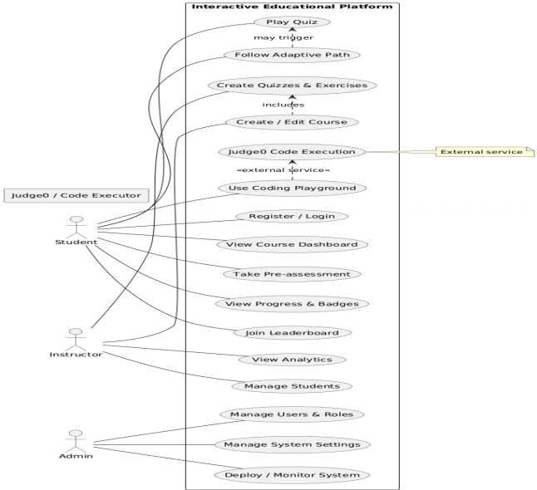

5.6 Class Diagram
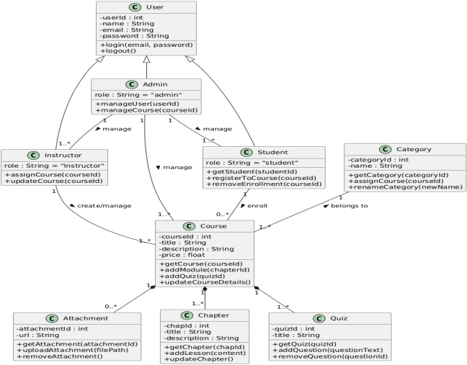

5.7 Sequence Diagram
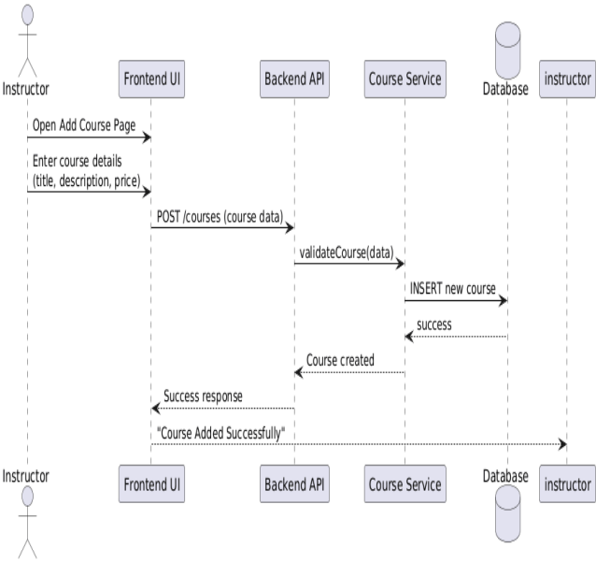
- ADD Course Sequence Diagram:

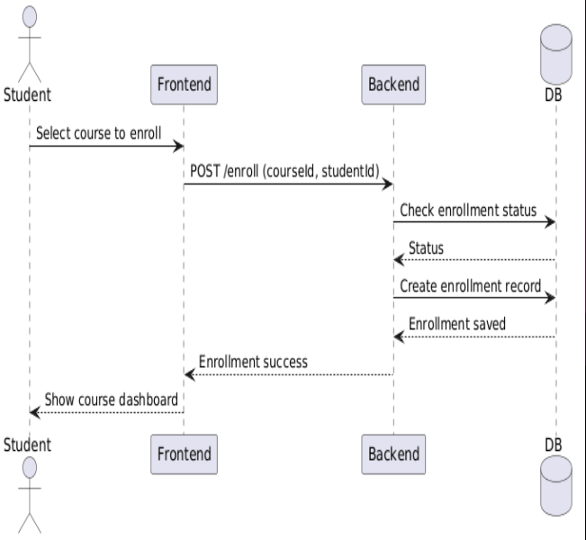
- Enroll in Course Sequence Diagram

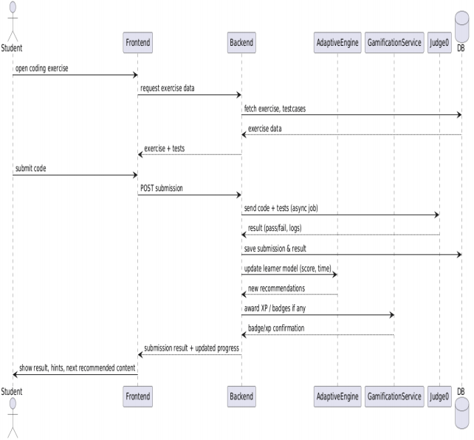
- Coding Exercise Sequence Diagram

5.8 Activity Diagram
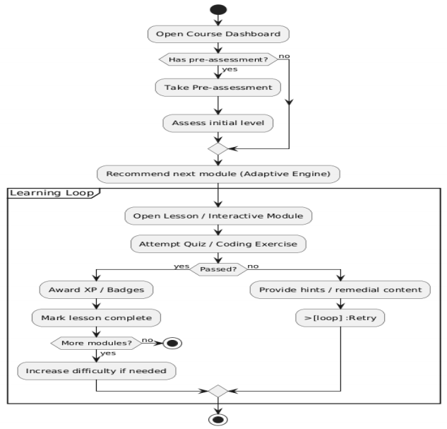

5.9 Entity Relationship Diagram (ERD)
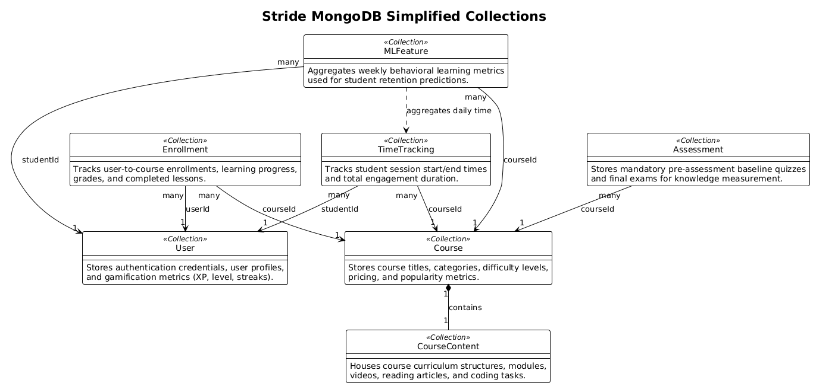

6.AI PLAN

6.1 RECOMMENDER SYSTEM: DETAILED DESIGN

6.1.1 Overview
The recommender system employs a hybrid layered approach to ensure robust and personalized discovery, effectively handling "cold start" scenarios for new users and courses.

6.1.2 Architecture Layers
- Layer 1: Content-Based Filtering: Represents courses as vectors derived from metadata using TF-IDF. We calculate cosine similarity between these vectors to find courses similar to those a user has already enrolled in.
- Layer 2: Collaborative Filtering: Identifies "neighbor" users with similar tastes and enrollment histories to recommend courses that the current user hasn't seen yet.
- Layer 3: Knowledge-Based / Rule-Based: Encodes explicit logic such as prerequisite checking and difficulty progression (e.g., don't suggest Advanced Python to a user who hasn't completed Intro to Python).
- Layer 4: Hybrid Model & Ranking: Gathers a broad pool of candidates from all layers and re-ranks them using a weighted formula that considers popularity, freshness, and relevance.

6.1.3 Recent Enhancements: Robustness & Explainable AI (XAI)
To prepare Stride for reliable, human-centric evaluation, several updates were implemented across the recommendation service to enhance robustness and explainability:
• Robust Level Progression & Prerequisites: Prerequisite validation was upgraded to perform case-insensitive, whitespace-trimmed title comparisons. Furthermore, difficulty progression rules were refactored to check if lower-level courses actually exist in the database for a given category. This protects the recommender engine from recommendation deadlocks when custom categories with only advanced courses are added.
• Explainable AI (XAI) Reasons: The hybrid ranking pipeline now dynamically computes a human-readable explanation (reason) for each recommended course. The React frontend presents these reasons directly in the user dashboard under each course card to increase trust and transparency. These include reasons such as: "Similar to [Completed Course Title]", "Building on your study of [Prerequisite Course Title]", or "Highly rated by students with similar profiles".
• Consistent Fallback Explanations: The Express API gateway fallback logic was aligned to attach category-based labels (e.g., "Similar course in [Category]") for course-to-course detail recommendations and general database recommendation fallbacks. This ensures a clean, explainable experience even when the Python microservice is offline.

6.2 STUDENT RETENTION: DROPOUT PREDICTION MODEL

6.2.1 Overview
To improve student retention, Stride incorporates an ML model that provides "Early Warnings" by analyzing behavioral data from the previous 7 days to predict dropout probability in the upcoming week.

6.2.2 Logic
- Data Points: Weekly login frequency, lesson completion rate, assessment/quiz performance, average engagement time, and interaction recency.
- Implementation:
  - Data Aggregation: Backend aggregates logs every Sunday.
  - Inference: Data is processed by the ML service to generate a Risk Score (0.0 to 1.0).
  - Classification: Students with a score > 0.7 are flagged as "At-Risk."
  - Intervention: These students are highlighted on the Instructor Dashboard for proactive outreach.

6.2.3 Feature List
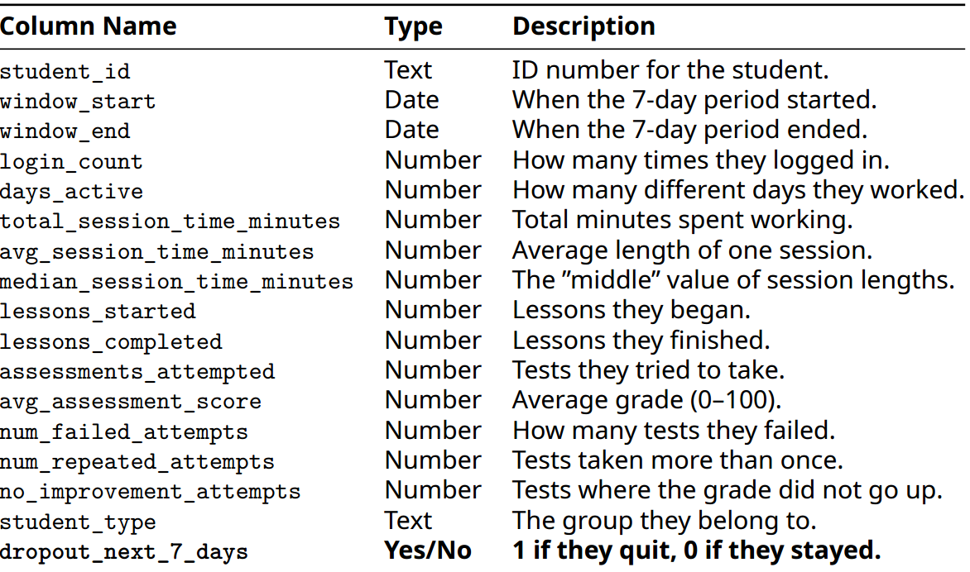

6.3 STUDENT DROPOUT MODEL EVALUATION RESULTS
To identify the most reliable estimator for predicting student dropout risk over the next 7 days, five machine learning models were optimized using 5-fold cross-validated grid search (GridSearchCV) and evaluated on a held-out test set ($20\%$ of the data).
6.3.1 Model Performance Summary
Model Name | Accuracy | Precision | Recall | F1 Score | AUC-ROC
Random Forest | 97.17% | 96.30% | 84.78% | 90.17% | 99.17%
Gradient Boosting | 79.33% | 45.16% | 23.73% | 31.11% | 60.50%
K-Nearest Neighbors (KNN) | 76.17% | 35.63% | 26.27% | 30.24% | 58.03%
Logistic Regression | 80.00% | 45.45% | 8.47% | 14.29% | 67.51%
SVC | 79.33% | 12.50% | 0.85% | 1.59% | 54.95%

7. SECURITY
Stride implements a multi-layered security strategy to protect user data, secure session states, control role-based permissions, and sandbox user code execution.
7.1 Authentication & Session Management
- Custom Credentials Authentication: User credentials and registrations are processed directly by the backend REST API. Passwords are securely hashed using bcrypt prior to database storage.
- JWT Tokens (JSON Web Tokens): Upon successful authentication, the Express backend issues a cryptographically signed JWT using jsonwebtoken that contains the user's ID, email, and role.
- Transmission Security: The token is passed via HTTP headers (Authorization: Bearer <token>) for all subsequent requests to the Express gateway and is encrypted in transit using HTTPS/TLS.
7.2 Role-Based Access Control (RBAC)
- Three specific roles are defined: Student, Instructor, and Admin.
- Backend Authorization Middleware: The backend enforces access control using an Express middleware pipeline:
  - verifyToken: Decodes and validates the JWT.
  - requireRole: Checks if the decoded user role matches the authorized roles (e.g. requireRole('admin'), requireRole('instructor')).
- Frontend Adaptations: The React Router and dashboard navigation dynamically adjust views based on the active role, but all key mutation operations are blocked by API-level guards.
7.3 Coding Sandbox Isolation & Safe Execution
Running arbitrary user code presents a security hazard (file access, infinite loops, memory leaks). Stride employs a dual execution model to mitigate this:
- Primary Sandbox (Vercel Sandbox): User-submitted code is sent to the Vercel Sandbox. It runs the untrusted script within a strictly isolated, containerized sandbox with resource limitations on execution time (e.g., 5 seconds), CPU usage, and RAM.
- Fallback Local Execution: When the sandboxed environment is unavailable, Stride spawns a local subprocess (child_process.spawn) configured with input/output piping (stdin/stdout). Code is checked against precise test assertions and wrapped within isolated wrappers.
7.4 Input Sanitization & Data Safety (SQL/NoSQL Injection)
- SQL Injection Immunity: Because Stride utilizes a NoSQL document database (MongoDB via Mongoose), it does not compile SQL queries or concatenate database strings, making it structurally immune to traditional SQL injection attacks.
- NoSQL Injection & Casting: Mongoose schemas enforce strict type validation. Request parameters are cast automatically (e.g., validating ObjectIds); query parameters containing unpermitted objects (like query operators {"$ne": null}) are either cast to strings or stripped, preventing NoSQL injection.
- Validation Middleware: All inputs are checked using express-validator middleware to block improperly formed payloads before they can reach the database or backend logic.
- CORS Configuration: Cross-Origin Resource Sharing (CORS) is restricted to allowed origins (local development and registered Vercel domains), protecting routes from cross-site scripts.
7.5 DDoS & Infrastructure Protection
- Edge Network Mitigations: Stride is designed to be deployed behind CDNs and hosting edges (like Cloudflare or Vercel). These platforms automatically intercept and filter volumetric DDoS traffic at the DNS and reverse proxy level.
- Request Sizing & Resource Limits: Payload size limits on HTTP requests (e.g., Express JSON bodies capped at 50MB) and strict sandbox resource constraints (5-second timeout on code execution) prevent resource starvation and buffer overflow Denial of Service (DoS) attempts.
7.6 Production Hardening & Security Risk Disclaimers
While Stride implements standard web security models, several vulnerabilities exist in development configurations that must be hardened prior to production deployment:
- Local Subprocess Code Execution Fallback:
  - Risk: If the sandboxing environment is not configured, Stride falls back to executing user-submitted Python code using the host machine's Python compiler via child_process.spawn. In a production environment, this allows malicious users to execute arbitrary code (e.g., read files, delete data, consume unlimited CPU/RAM resources, or spawn reverse shells) directly on the host machine.
  - Hardening Recommendation: Disable the local subprocess fallback in production. The system should throw an error and halt execution if the sandboxing configuration is missing or invalid.
- Weak JWT Secret Fallback:
  - Risk: In auth.js and index.js, the JWT token secret defaults to a hardcoded string 'secret' if the ACCESS_TOKEN_SECRET environment variable is not defined. Attackers can forge administrative tokens using this default key to compromise any user account on the platform.
  - Hardening Recommendation: Enforce application failure at start-up if ACCESS_TOKEN_SECRET is missing, weak, or set to the default value in a production environment.
- Mock Stripe Payment Handling:
  - Risk: In index.js, Stride automatically falls back to generating mock Stripe client secrets and successful mock checkouts if STRIPE_SECRET_KEY is not set.
  - Hardening Recommendation: Force Stripe connection checks and fail API start-up if the key is missing in production to prevent bypasses or billing oversights.

8. TESTING
Stride features a comprehensive automated testing suite covering Express API handlers, the recommender system, and the dropout prediction microservice to ensure operational logic and correctness.
8.1 Testing Scope & Frameworks
The project maintains a 100% pass rate across all test suites:
- Node.js Express Backend (11 Tests): Evaluated using the Node.js v24 native Test Runner (node:test) and assertion library (node:assert). Mongoose collection methods are stubbed in-memory to execute tests without requiring active database connections.
- Python Recommender Service (6 Tests): Evaluated using standard Python unittest. Covers TF-IDF content calculations, collaborative filtering Jaccard overlaps, case-insensitive prerequisite checks, and deadlock-free difficulty progression.
- Python Dropout Prediction Service (1 Test): Evaluated using standard Python unittest. Validates the metric normalization pipeline and risk level classification thresholds.
8.2 Inventory of All Automated Test Cases
Node.js Express Backend Unit Tests
1. authController.test.js
- register should create a user and return JWT token: Verifies that new users are successfully registered with hashed passwords and a valid JWT token is returned.
- register should fail if user already exists: Enforces user uniqueness by rejecting registrations containing emails already stored in the database.
- login should log in existing user with correct credentials: Validates credentials via bcrypt compare and issues a JWT token to establish the user session.
2. courseController.test.js
- getAllCourses should return all active courses: Verifies that the catalog retrieval API returns all courses flagged as active or published.
- getCourseById should return 400 for invalid ObjectId format: Enforces strict MongoDB ID formatting, blocking malformed string parameters.
- getCourseById should return 404 if course not found: Returns a proper Not Found status when a valid but non-existent course ID is requested.
- updateCourse should return 403 if instructor is not the owner: Enforces CMS ownership rules, blocking unauthorized modification of other instructors' courses.
3. assessmentController.test.js
- getAssessment should strip correct answers for MCQ and matching questions: Asserts student exam integrity by wiping correct answers from assessment payloads before sending them over the wire.
- submitAssessment should calculate correct score and award XP: Validates the auto-grading math (MCQ/True-False/Matching) and awards learning progression XP corresponding to the achieved score.
4. codeEvaluationController.test.js
- evaluateCodeSubmission should fail if language is not Python: Enforces runtime restrictions by rejecting unsupported coding languages.
- evaluateCodeSubmission should execute code using mocked sandboxed execution API: Verifies the batch execution orchestration and grade results returns via mock sandbox endpoints.

Python Recommender Service Unit Tests (test_recommender_logic.py)
- test_layer1_content_based: Validates TF-IDF content similarity scores on course descriptions and filters out courses the student has already enrolled in.
- test_layer2_collaborative: Validates user-to-peer neighborhood overlap scores using Jaccard index similarity matrices on enrollment history.
- test_layer3_rule_based_prerequisites_met: Enforces progression path checks to ensure that course prerequisite requirements have been met.
- test_layer3_rule_based_case_insensitive_prerequisites: Validates case-insensitivity and whitespace trim safety within the prerequisite comparison logic.
- test_layer3_rule_based_deadlock_prevention: Resolves "cold start" progression locks by recommending advanced courses if no lower-level courses exist in the category.
- test_layer4_ranking_reasons: Verifies weighted hybrid ranking scoring and dynamic XAI reason string generation ("Similar to...", "Building on...").

Python Dropout Prediction Service Unit Tests (test_dropout_service.py)
- test_dropout_predictor_logic: Validates that 12 raw behavioral metric vectors are properly scaled and predicted as low or high risk by the Random Forest pipeline.

9. DEPLOYMENT
9.1 Production Cloud Architecture
Stride uses a modular cloud architecture to deploy the platform efficiently and separate frontend, backend, database, and AI microservice workloads:
- Frontend (Vercel): Deployed to Vercel's global CDN. Client-side navigation routes and asset caching are handled directly via a vercel.json configuration file.
- Backend REST API (Vercel Serverless): Deployed to Vercel Serverless Functions, scaling automatically with student traffic.
- Database (MongoDB Atlas): Hosted on a managed cloud database cluster with automatic scaling, replication redundancy, and daily backups.
- AI Microservices (FastAPI): Packaged and hosted on containerized PaaS platforms (e.g., Render, Railway, or virtual private servers) behind a high-performance Uvicorn ASGI server.
9.2 Code Sandbox execution & Failover Pipeline
To guarantee consistent code execution feedback for students even during external sandbox outages or API rate limit caps, Stride implements a three-tier failover pipeline:
graph TD
A[Student Code Submission] --> B{1. Vercel Sandbox}
B -- Success --> C[Return Code Output & Test Results]
B -- Failure / Rate Limit --> D{2. Piston API Public Fallback}
D -- Success --> C
D -- Failure --> E{3. Local Subprocess Exec Dev Only}
E -- Success --> C
E -- Blocked in Prod --> F[Error: Execution Sandbox Offline]
Pipeline Tiers:
- Primary Sandbox (Vercel Sandbox): Runs untrusted user code in strictly isolated, containerized Firecracker microVMs with resource limitations (CPU, RAM, 5s timeout).
- Secondary Fallback (Piston API): A high-performance public multi-language execution engine that acts as a failover when primary VM limits are reached.
- Tertiary Local Fallback (Local Subprocess): Spawns a piped shell process on the server machine. Restricted to Local Development Only and disabled in production environments for safety.

10. WORK PLAN
10.1 Project Timeline & Task Breakdown
Task # | Task Title | Description | Status | Timeline
1 | Project Kickoff & Requirements Gathering | Define project scope, stakeholders, and initial requirements | Completed | Week 1
2 | Technology Stack Selection | Evaluate and select React, Express, and MongoDB | Completed | Week 2
3 | System Architecture Design | Design overall system architecture and component structure | Completed | Week 2-3
4 | Authentication Module | Custom Auth integration, login/register pages | Completed | Week 3
5 | Home page | Landing page with latest courses and footer | Completed | Week 4
6 | Navbar & Navigation | Responsive navbar with role-based menus | Completed | Week 4-5
7 | Course Catalog Page | Course listing with search, filter, and sorting | Completed | Week 6
8 | Course Detail Page | Individual course page with metadata and enrollment | Completed | Week 6-7
9 | Lesson Content Delivery | Article, video, quiz, and coding lesson components | Completed | Week 8
10 | Quiz System | Interactive quiz component with multiple question types | Completed | Week 9
11 | Student Dashboard | Progress overview, enrolled courses, recommendations | Completed | Week 10
12 | Instructor Dashboard | Course management, student analytics | Completed | Week 10
13 | Admin Dashboard | User management, course oversight | Completed | Week 11
14 | Coding Exercise Component | Monaco Editor integration for code lessons | Completed | Week 12
15 | Database Schema Design | Design ERD and database schemas | Completed | Week 13
16 | Machine learning model | Build an ML model to predict drop-out students | Completed | Week 14
17 | Recommendation Engine | Hybrid 4-layer recommendation service | Completed | Week 15
18 | Backend Architecture Setup | Node.js/Express project initialization | Completed | Week 16-17
19 | Database Setup | MongoDB configuration and connection | Completed | Week 18
20 | Authentication API | JWT token generation, auth middleware | Completed | Week 19
21 | User Management API | User CRUD operations and profile management | Completed | Week 20-21
22 | Course Management API | Course CRUD, sections, lessons endpoints | Completed | Week 21-22
23 | Enrollment API | Enrollment tracking and student course linking | Completed | Week 22
24 | Quiz/Assessment API | Quiz submission, answer validation, score calculation | Completed | Week 23
25 | Progress Tracking API | XP system, level progression, course completion | Completed | Week 23-24
26 | Recommendation API | Backend recommendation logic implementation | Completed | Week 24
27 | Unit Testing | Component and function unit tests | Completed | Week 25
28 | Integration Testing | API and feature integration tests | Completed | Week 25-26
29 | User Acceptance Testing (UAT) | End-to-end testing with stakeholders | Completed | Week 26
30 | Deployment | Deploy frontend and backend to cloud | Completed | Week 27-28
31 | Documentation | Setup guides, architecture docs | Completed | Week 28
32 | Final Project Report | Comprehensive project documentation | Completed | Week 28

